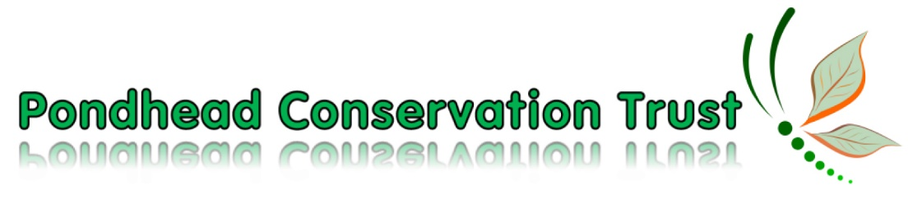
RISK ASSESSMENT – COVID 19

This risk assessment should be read in conjunction with the risk assessment for the relative task being undertaken
- If you are feeling unwell or running a temperature, it is paramount that you stay at home and do not attend.
- You will be asked by the task leader to provide an up-to-date contact telephone number at the start of each event to enable track/trace to take place if necessary
- The social distancing rule of at least 1 metre should be observed wherever possible
- The number of volunteers will be limited to 12 on each task to ensure that social distancing is achievable
- Hand sanitiser (80% alcohol) will be available on all tasks to enable appropriate hand hygiene. In each individual volunteer’s interest this should be used prior to consuming food/drinks during coffee and lunch breaks
- Tools should not be shared if possible.
- Gloves must be always worn when using tools. Any handles you touch without gloves should be wiped down immediately after use. There will be bacteria/virus disinfectant wipes on site with the task leaders.
- Do not share gloves. Please bring your own gloves – we have a small supply of new ones if you need some. Ask the task leader.
- If you prefer to work with safety glasses, please either bring your own or we will supply you with a pair to keep. Ask the task leader.
- Task leaders to wipe down tools with disinfectant wipes at the end of each event
- Do not share any food utensils
- If you subsequently develop Covid symptoms, please advise us immediately via info@pondheadconservation.org.uk
REMEMBER
While we all need to follow the above simple rules, the risk of contagion is much less outdoors than indoors in shops, etc.
STAY ALERT & ENJOY YOUR TIME IN PONDHEAD

Updated 9.21

